Phase 2 Source
UMGC CMSC 495 Section 6384
Arora, Neil
Pierce, Holden
Stigall, Michael
Thompson, Kosie

Introduction
Phase 2 of the Breakout-style arcade game project builds upon the stable and playable foundation established in Phase I. During this phase, the team transitions from delivering a Minimum Viable Product (MVP) to refining the application into a production-ready implementation. Emphasis is placed on finalizing core gameplay systems, improving modular structure, strengthening state management, expanding unit test coverage, and enhancing documentation quality.
The project continues to use Python and Pygame within a structured and version-controlled environment, ensuring consistency across development machines. Phase 2 focuses on code refactoring, performance stability, and clean architectural separation between gameplay entities, managers, and UI components. Additionally, comprehensive automated testing using pytest supports reliability and regression prevention.
By emphasizing maintainability, scalability, and correctness, Phase 2 prepares the Breakout game for final submission while demonstrating mastery of software development best practices, including structured design, collaborative workflows, testing strategy implementation, and deployment readiness.

Project Setup
During Phase 2, the project setup was re-evaluated and finalized to ensure consistency, maintainability, and production readiness. Development continues to be conducted using Visual Studio Code as the primary Integrated Development Environment (IDE), configured with the appropriate Python extensions to support linting, debugging, and streamlined execution. The project environment is standardized according to the Python and Pygame versions documented in the ReadMe file to ensure compatibility across all team members’ machines.
The Pygame library remains the primary framework responsible for rendering, input handling, and real-time game loop management. Automated testing continues to utilize the pytest framework to validate non-graphical components and ensure regression prevention. All required dependencies and setup instructions are clearly documented in the repository’s ReadMe to enable reproducibility of the development environment.

1.1 Configuration Centralization
To improve maintainability and reduce code duplication, the project centralizes configuration constants within the Core/config.py module. This file defines shared values such as screen dimensions, frame rate (FPS), paddle speed, ball speed, scoring values, and default life counts. Gameplay entities including Ball, Paddle, Level, and UI systems import these constants rather than hardcoding values locally.
Centralizing configuration ensures consistent behavior across modules and allows gameplay tuning or display adjustments to be performed from a single location. This approach reduces the risk of conflicting values, simplifies debugging, and supports scalability as additional features are implemented in Phase 2.

1.2 Version Control Workflow
The project repository is maintained using Git and hosted on GitHub. For this capstone implementation, the team follows a disciplined single-branch workflow using the main branch. Although feature branching is available, the team elected to use a controlled main-branch approach due to the project’s scale and team size.
Before committing updates to the repository, team members are expected to:
- Run the full pytest suite to confirm all automated tests pass
- Perform smoke testing to validate gameplay stability (launch, paddle movement, ball collision, block destruction)
- Verify no regressions or runtime errors occur
The repository includes a properly configured .gitignore file to exclude Python cache files, IDE configurations, and temporary artifacts. This ensures the repository remains clean and focused on source code, assets, and documentation.

1.3 Project Structure Verification
During Phase 2, the project directory structure was reviewed and confirmed to support modular architecture and separation of concerns. The structure clearly separates gameplay objects, managers, UI components, configuration files, tests, and assets. This organization improves readability, simplifies debugging, and supports future enhancements such as additional levels, expanded UI systems, and advanced state management.
By finalizing the development environment, configuration management, repository workflow, and project structure, Phase 2 establishes a stable and production-ready foundation for completing core functionality and preparing the Breakout game for final submission.

2 Core Functionality

2.1 Implementation Features

2.2 Choice of Algorithms

2.3 Modular Components

3 Documentation / Impelmentation of Code
This section describes the documentation practices and implementation standards used throughout Phase 2 of the project. Our team prioritized readability, consistency, and maintainability to ensure that all contributors could easily understand and extend the codebase. Each module follows a clear organizational structure, and classes are designed to encapsulate individual gameplay responsibilities.
Inline comments are used to clarify non-obvious logic, particularly within collision handling, movement updates, and level loading. Method names and variable names were selected to be descriptive and consistent across modules. Configuration values such as screen dimensions, movement speeds, and default object sizes are centralized in the Core configuration files, reducing duplication and simplifying future tuning.
External documentation is provided through the project’s ReadMe.md file, which outlines installation steps, required dependencies, and instructions for running both the game and automated unit tests. This ensures that new contributors can quickly configure their development environment and verify functionality.
The implementation emphasizes modular design by separating gameplay entities (Ball, Paddle, Block, Level) from supporting systems such as input handling, collision management, and scoring. This structure improves maintainability and enables incremental development in later phases.

3.1 Example of Comments
Code comments are used to explain key logic and document intended behavior. For example, within the Block class, comments describe the purpose of each method and clarify how damage is applied to blocks during gameplay. Similar documentation exists within the Ball and Paddle classes to explain movement calculations and collision boundaries.
Concise inline comments accompany critical sections such as collision detection, velocity updates, and level loading, ensuring that future contributors can quickly understand how each subsystem operates.
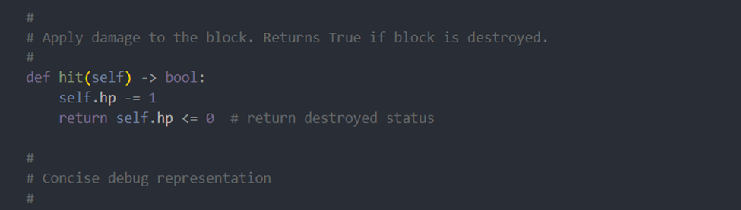
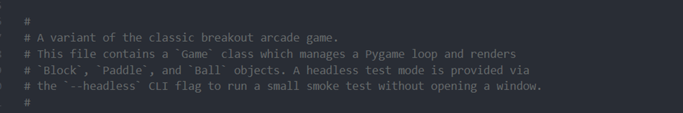

3.2 Example of Smoke Tests
We performed basic smoke testing by launching the game and verifying that essential gameplay mechanics functioned correctly. Functions such as the following: paddle movement, ball physics, block collisions, score updates, and life loss behavior. These manual checks confirm that the application starts successfully and that the primary gameplay loop operates as expected.
In addition to manual smoke testing, automated unit tests were introduced early in development to validate core object behavior independently of the full game loop. This includes tests for Block initialization, hit logic, and bounding rectangle generation. These tests help detect regressions quickly and provide confidence that core gameplay components remain stable as development continues.

4 Unit Testing

4.1 Major Functionality to Test

4.2 Unit Testing Framework

5 Conclusions
Phase 2 transitions the Breakout game from a functional prototype to a production-ready application. Through the centralization of configuration, the team has established a codebase that is significantly more maintainable and easier to tune. The disciplined version control workflow, combined with rigorous smoke testing prior to each commit, has ensured project stability and prevented regressions as new features were integrated.
The finalization of core features delivers a complete and polished player experience. The implementation of these features using clear and efficient algorithms demonstrates sound software engineering principles. The modular architecture provides a scalable foundation that could easily accommodate future enhancements like power-ups, new block types, or additional visual effects.
Most importantly, Phase 2 has established a benchmark of quality through comprehensive documentation and unit testing. The code is now consistently formatted and commented, with clear docstrings explaining the purpose and logic of key components. By meeting all criteria in the project rubric for documentation, unit testing, and core functionality, Phase 2 has fully prepared the Breakout game for finality and demonstrates a mastery of collaborative software development best practices.

